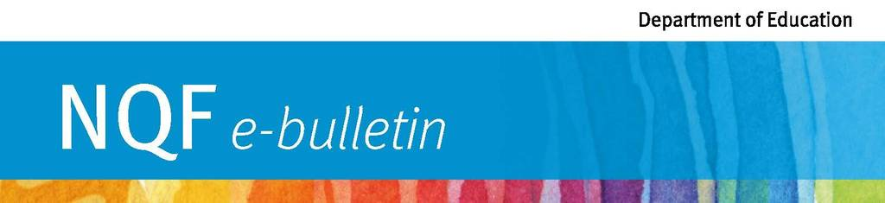

Spotlight on safety: Button batteries
Does your early childhood service have strategies in place to protect children from the danger posed by button batteries?
Button batteries power many household items, from watches to hearing aids and remote controls.
These small, shiny batteries are attractive to small children and, if swallowed or inserted, can cause serious internal burns or death. Even flat batteries contain enough electrical current to seriously injure a child when swallowed.
Approved providers, nominated supervisors and family day care educators have obligations under the Education and Care Services National Law to ensure all reasonable precautions are taken to protect children from harm and hazard.
Approved providers can reduce the risks to children’s health and safety by:
- keeping button battery-powered products to a minimum
- having strategies in place for the safe storage and disposal of used batteries
- regularly inspecting button battery-powered toys and electronic devices and ensuring the battery compartments are secure
- ensuring toys and books that are brought in from home are carefully inspected and do not pose a risk to children’s health and safety
- sharing important safety information with families and children.
Only products designed for children under three are required to have secure battery compartments that pass drop testing. To reduce risk, approved providers should consider buying only products that:
- require a screwdriver to open the battery compartment
- are secured with a child-resistant locking mechanism
- require two independent and simultaneous movements to access.
You can report unsafe products to the Office of Fair Trading and the Australian Competition and Consumer Commission.
Serious internal burns can develop quickly. If educators suspect a child has swallowed or inserted a button battery, they should call 000 or the 24/7 Poisons Information Centre immediately on 13 11 26.
More information
More information on product safety advice and warnings is available on the Queensland Government and Kidsafe websites.
Visit our website | Contact us | Subscribe to A to Z of Early Childhood monthly e-newsletter for more information about early childhood education and care initiatives in Queensland. | 2 October 2018 |

