Report a Safety Incident by Scanning the QR Code

Overview
This page explains how to use a mobile phone to report a safety incident such as a slip or fall.
This process allows anyone to report an incident or concern just by scanning a QR code and typing some details on their phone. You do not need a username or password to do this.
The aim is to provide a simple process for everyone to use easily while providing enough information to allow for follow up action.
Scope
The reporting process can be used by everyone including hall hirers, church members and visitors to Uniting Churches across the Queensland Synod.
What you will need
You will need:
- A mobile phone
- A copy of the Speak Up poster or business card. If you don’t have access to one, you can scan the QR code below.
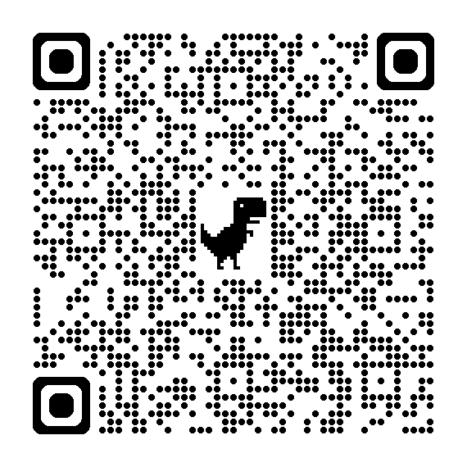
Scan the QR Code
Scan the QR code either on the poster or business card or the one above.
The incident report form will open on your phone.

There are four sections to complete:
- Details
- Person
- Safety Assessment
- Affected Person’s Details.
Details
Enter details for:
- Your name – the person reporting the incident.
- Contact Number – so someone can follow up with you.
- Email address – if you include an email address, the system will send you a confirmation email.
- Location – click in the field and start typing the name of your congregation e.g. Bundaberg Uniting Church. The system will automatically fill in the rest of the name.
- Incident type - select Incident.
- Details – describe what happened.
- When did this happen – include date and time.
- Does this affect a - choose Person.
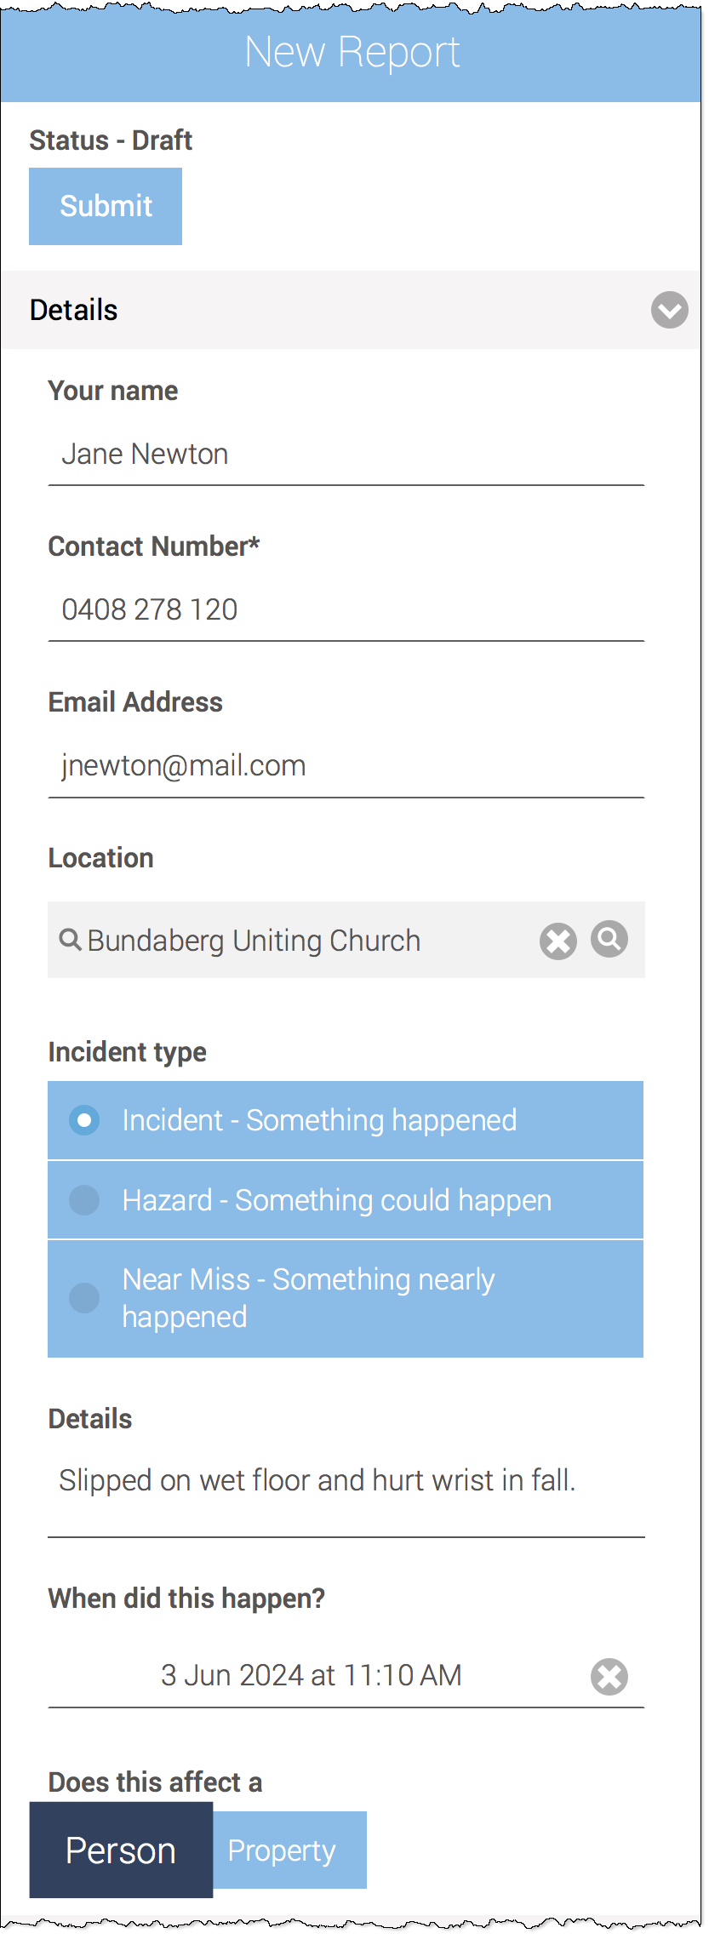
Figure 1: Details section
Person
- Was the person or could the person have been – Choose Injured or unwell.
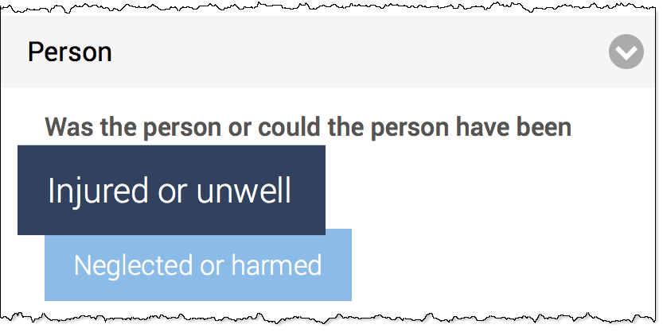
Safety Assessment
- Is or was anyone in danger? – was there a danger to anyone such as live electrical current or fire etc.?
- How was the danger addressed? – if there was such a danger, how did you deal with it?
- Were other people removed from the situation? – did you need to move anyone away from the danger?
- Was an ambulance called?
- Were the police called?

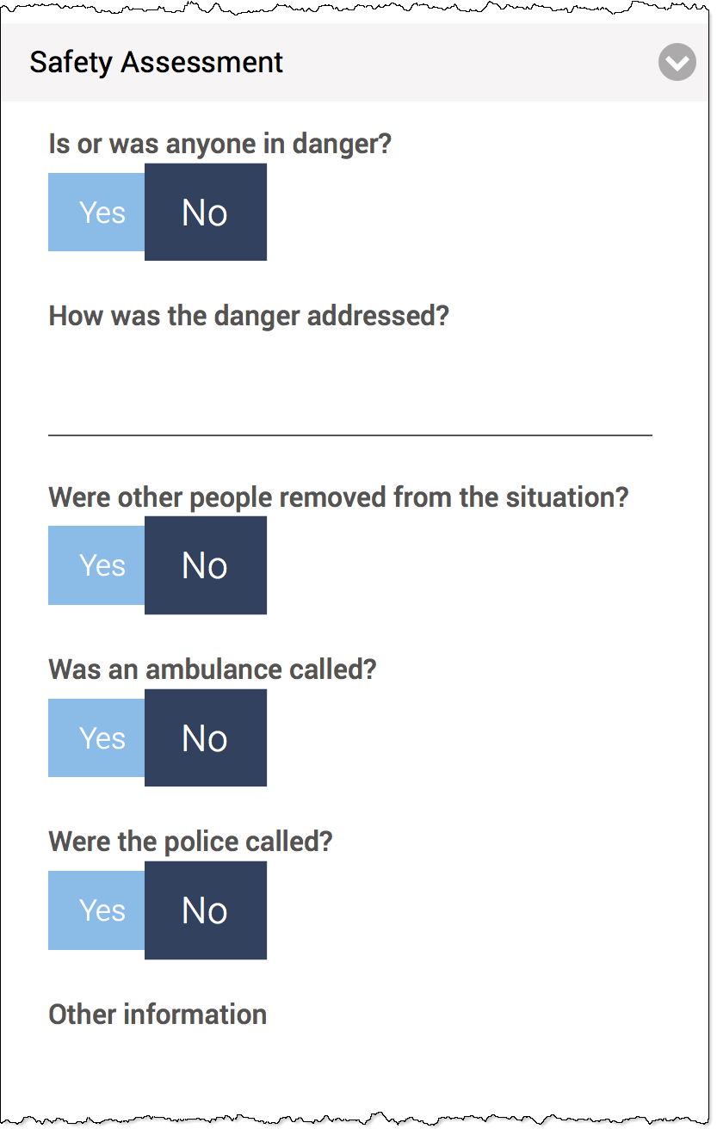
Affected Person’s Details
Name – the name of the affected or injured person.
Contact Number – the affected or injured person’s phone number.
Email Address – the affected person’s email address.
Affected Person is unknown – tick this box if nobody knows the affected or injured person.
Severity – choose a level of severity from the list. Because we’re dealing with someone's health, note the first part of each statement and base your choice on the first part of the statements e.g. first aid.
The severity options are:
- Fatality/total loss fire – choose if someone has lost their life in the incident.
- Hospital admission/major fire damage – choose if the affected person has been admitted to hospital.
- Medical treatment/minor fire damage – choose if the affected person needed to be treated or assessed by a doctor.
- First aid/blew a fuse – choose if only first aid was needed.
- No first aid needed/burnt the toast – choose if no first aid was needed.
- Person exposed to serious risk or harm – certain events are classified as Dangerous Incidents and need to be handled in accordance with law. Check the Worksafe Qld page for more detail.
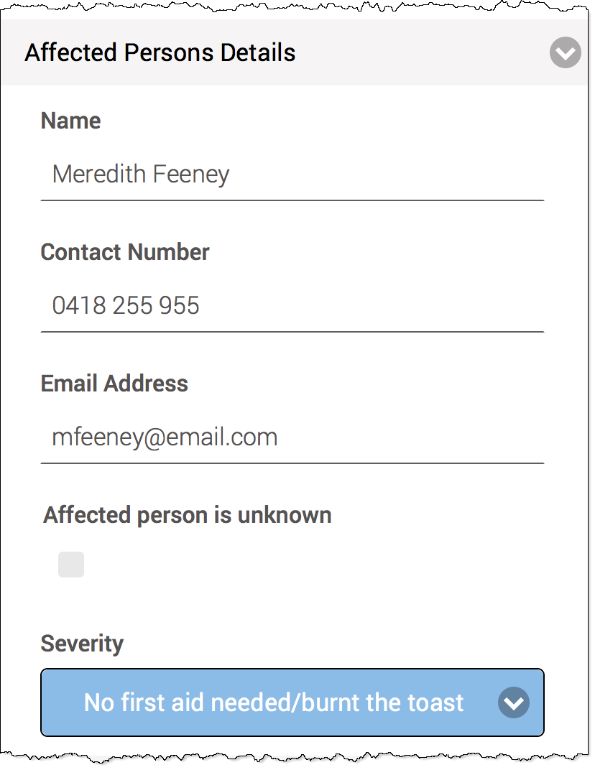

Save
Click Save or Save and Close at the bottom. Either option will ensure your report is saved.

Follow up
The details of your report will be forwarded to different people depending on the severity.
For minor incidents not needing first aid or medical treatment, the system will notify a congregation minister, church council chair or the equivalent.
If anyone is admitted to hospital or in the event of a person exposed to serious risk or harm, the Synod Office will be notified and will work with you.
If you have included an email address in the Details section, the system will send you a confirmation email.

Contacts for serious incidents
You can call the Synod Office on the numbers below instead of using the QR code process or if your incident is more urgent or serious.
- Injury and illness – 07 3377 9870
- Synod after hours urgent matters – 07 3377 9706
Revisions
Document number
Version | Approval date | Approved by | Effective date | Policy owner | Policy contact
1.0 | 03.06.2024 | Program Manager (Risk and Assurance) | 03.06.2024 | General Manager – Risk & Safeguarding | Program Manager (Risk and Assurance)
Next scheduled review |  | 03.12.2024

