Report Property damage or maintenance with a link on a computer

Overview
This page explains how to use a computer to report a property issue such as a broken window or leaking roof.
This process allows anyone to report an incident or concern just by clicking a link and typing some details on their computer. You do not need a username or password to do this.
The aim is to provide a simple process for everyone to use easily while providing enough information to allow for follow up action.
Scope
The reporting process can be used by everyone including hall hirers, church members and visitors to Uniting Churches across the Queensland Synod.
What you will need
You will need:
- A computer
Link
Click the link to report new incident.
The incident report form will open on your computer.

There are three sections to complete:
- Details
- Safety Assessment
- Property.
Details
Enter details for:
- Your name – the person reporting the incident.
- Contact Number – so someone can follow up with you if required.
- Email address – if you include an email address, the system will send you a confirmation email.
- Location – click in the field and start typing the name of your congregation e.g. Bundaberg Uniting Church. Choose your location once you see it appear. If you see a warning that the text doesn’t match existing records, click into the next field and the message will disappear.
- Incident type - select Incident – Something happened.
- Details – describe what happened.
- When did this happen – include date and time.
- Does this affect a - choose Property.
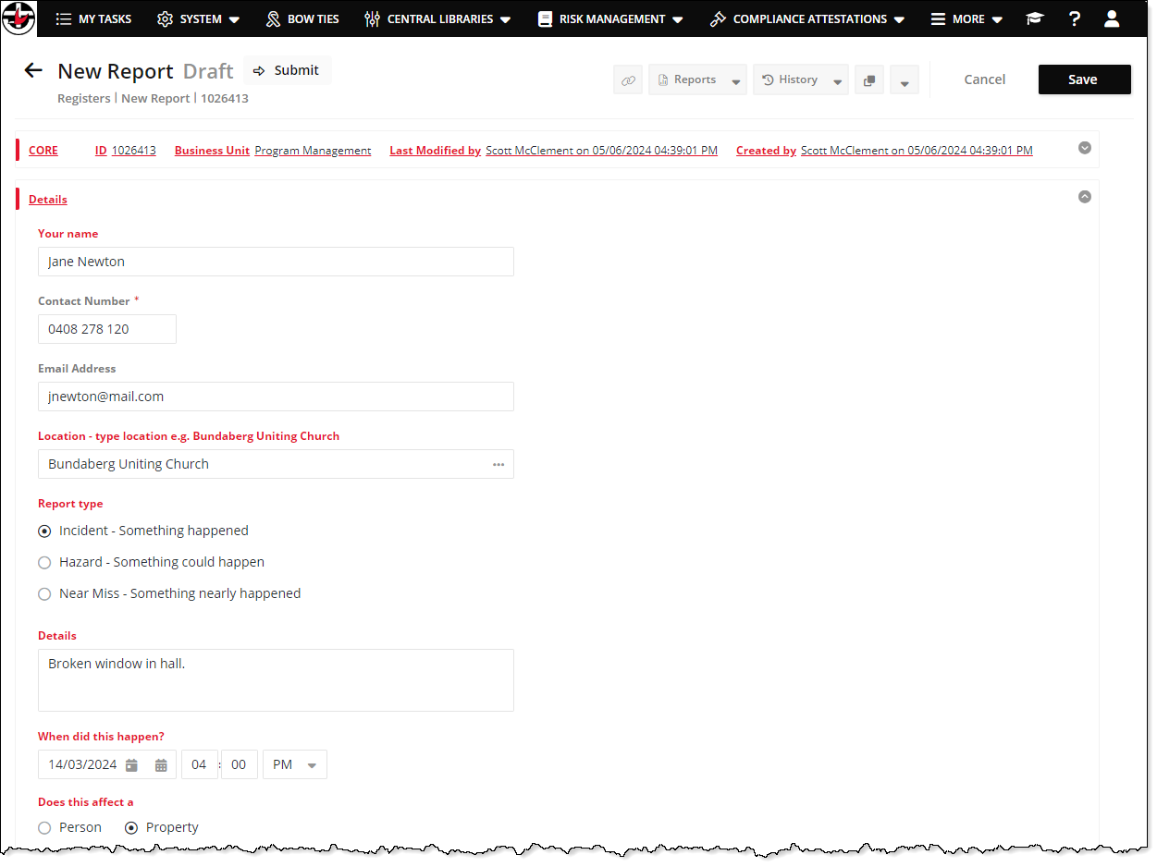
Figure 1: Details section
Safety Assessment
- Is or was anyone in danger? – was there a danger to anyone such as live electrical current or fire etc.?
- How was the danger addressed? – if there was such a danger, how did you deal with it?
- Were other people removed from the situation? – did you need to move anyone away from the danger?
- Was an ambulance called?
- Were the police called?

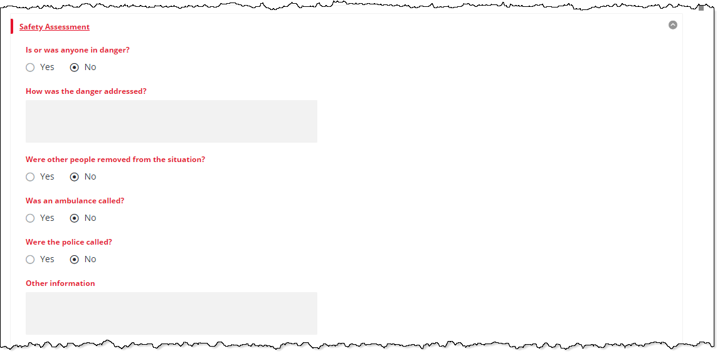
Figure 3: Safety Assessment section
Property
- What has been damaged – describe the affected property.
- Images – if you have photos of the damage, you could upload them here. Either drag the photos onto the left pane or click + and navigate to select them from your computer.
- Did it cause a safety risk – did the damage cause any risk?
- Did it cause a security issue – does the damage make it easy to break in?
- Has it been secured? – Has the security been sorted out now?
- Does anything need to be done to prevent further damage?

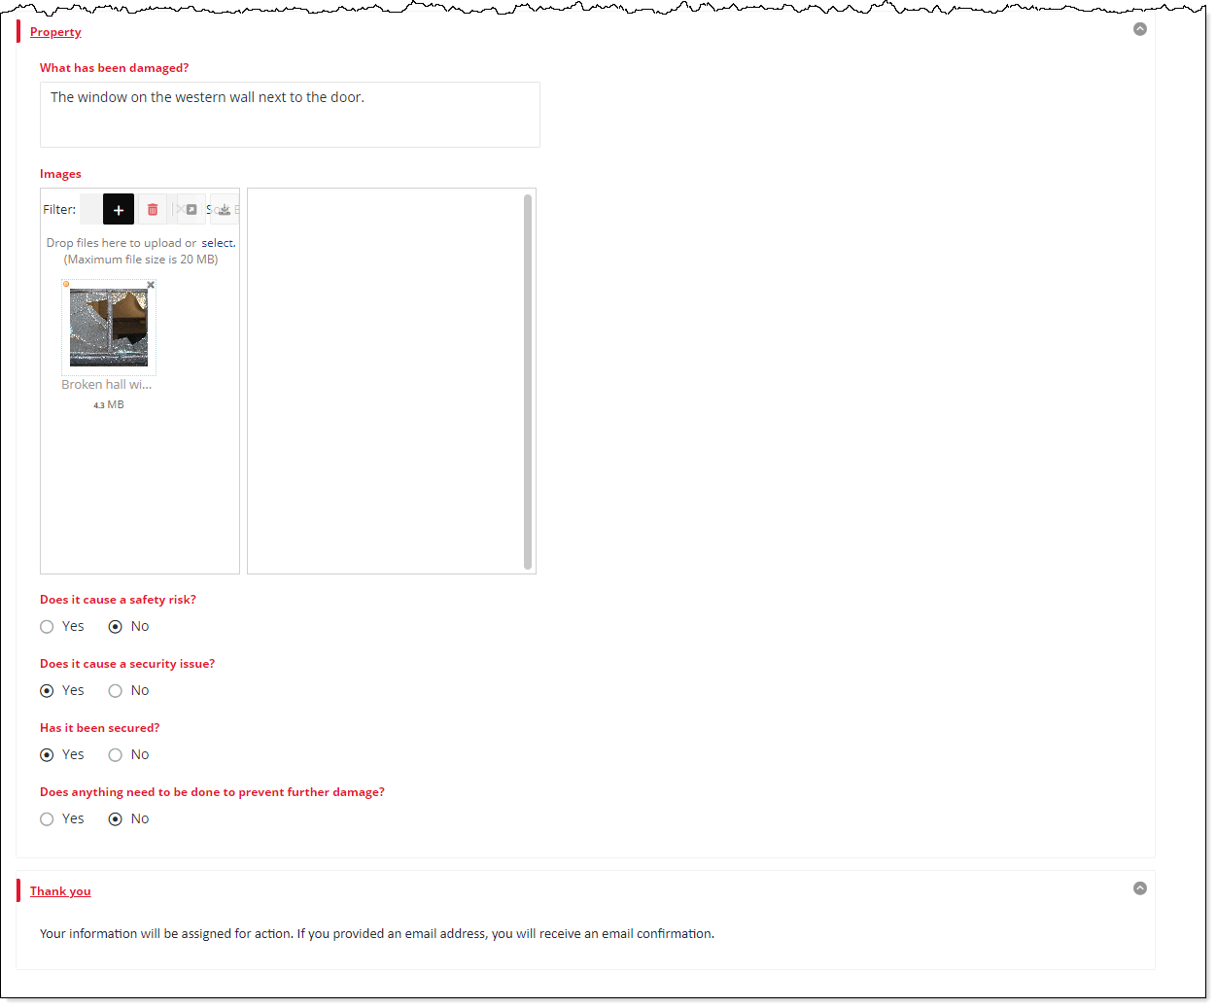
Figure 4: Property section
Save
Click Save.
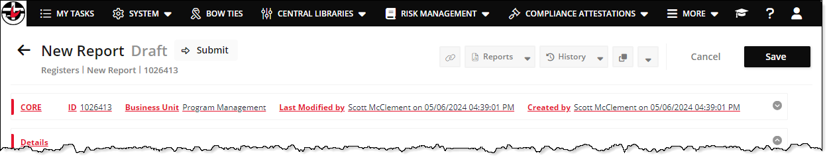
Figure 5: Save your incident report
Follow up
If you have included an email address in the Details section, the system will send you a confirmation email.
Contacts for serious incidents
You can call the Synod Office on the numbers below instead of using the above process or if your incident is more urgent or serious.
- Injury and illness – 07 3377 9870
- Synod after hours urgent matters – 07 3377 9706
Revisions
Document number
Version | Approval date | Approved by | Effective date | Policy owner | Policy contact
1.0 | 03.06.2024 | Program Manager (Risk and Assurance) | 03.06.2024 | General Manager – Risk & Safeguarding | Program Manager (Risk and Assurance)
Next scheduled review |  | 03.12.2024

