Ocean Sunday
(Australian Version 1)

Introduction

Ocean refers to the mass of waters that cover two thirds of Earth’s surface, the swirling seas and the watery deeps where myriads of species live, many of which are still undiscovered. The ocean is a world of mystery and beauty, of fascinating depths and spectacular life forms. The ocean is that vast domain many of our ancestors crossed to reach all parts of planet Earth. And the waters of the oceans are ultimately the waters of life for all the planet.

Setting

To capture the world of the ocean in worship, it is helpful to create a sense of life in the deep with images of sea creatures on the walls, scenes of rich color and mystery, whales, dolphins, sea lions, angel fish, albatross and so on. Another option is for the children to process into worship as if they were boat people, sailing on a series of sailboats, holding images of life at sea. The church floor then becomes the surface of the ocean. The community worships at sea! Some of the children could be whales, penguins or dolphins swimming alongside the boats. Scientists and artists in the community may help with conceptualizing the ocean as a living part of our planet.

Special Focus

A special focus for this service is the unique nature of our oceans as vast living worlds and the many unknown domains that both surround and continually surprise us.

Themes

In our call to worship we invite all the domains of the oceans to worship with us, even those we have never seen. In our confession to recall how we have started killing our oceans by over-fishing with nets, introducing alien species, polluting with massive waste emissions and killing our coral reefs with global warming. We celebrate the ocean as the source of our waters, the precious waters of life that make this planet unique. Throughout Series C for the Season of Creation we are conscious that, according to the Scriptures, Wisdom is both and agent and impulse active in creation.

Optional Liturgies

Another Earth liturgy, which draws on the rich traditions of Psalm 104 and provides additional options is entitled Song of Water and appears in Seven Songs of Creation, published by Pilgrim Press (2004).

Songs

A special song/hymn appropriate for this Sunday is located in Habel Hymns Volume One. The melody is the well-known Praise, my Soul, the King of Heaven. The words follow.

SONG OF THE WATERS

1. Watch once more the windswept storm clouds;
Suddenly the sky has wings!
God has come to rain among us,
Giving hope to all dry things.
Sing a song of splashing waters,
Pulsing through the veins of Earth.

2. Taste the moisture of the morning,
Smoother than the best red wine;
Toast the lifeblood of the planet:
Here’s to God’s wild wet design!
Sing a song of flowing waters,
Pulsing through the veins of Earth.

3. View anew the dark blue ocean,
Whales cavorting, spraying foam;
God at play with deep sea monsters,
Feeling very much at home.
Sing a song of laughing waters,
Pulsing through the veins of Earth.

4. Feel the breath of God move softly,
Gentle mists that brush the skin;
Earth is breathing God’s own spirit,
Life renewed from deep within.
Sing a song of living waters,
Pulsing through the veins of Earth.

Words: © Norman Habel 2001

First Sunday in the Season of Creation
(Australian Version 1)

Ocean Sunday
We worship with the surging seas

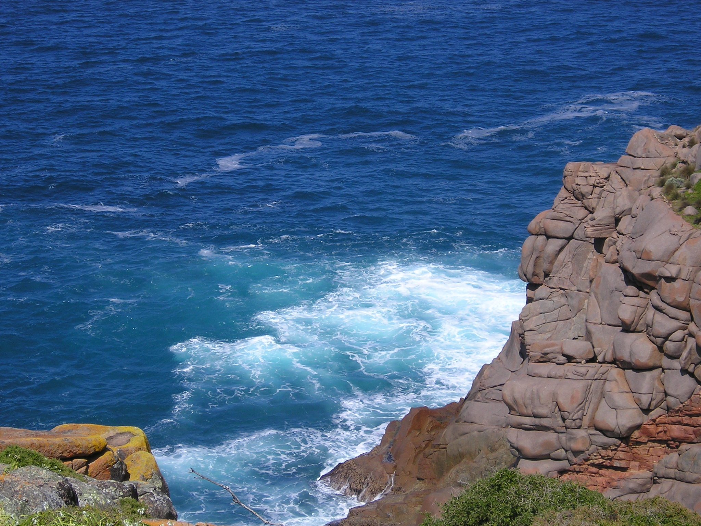

“Let the sea roar and all that fills it!” Ps. 96.11

OCEAN SUNDAY

Welcome!
We worship this Sunday with the oceans of Earth, all designed by the Wisdom of God. We join the Psalmists and call the sea to roar with songs of praise. We sing with the swirling seas and celebrate with the wondrous creatures of the watery deep. With our Creator, we rejoice with whales, dolphins and other ‘sea monsters.’ With the Spirit we groan with species that are suffering from human acts of pollution.

Gathering

Leader In the name of the Spirit of God
who hovered over the primal waters.
In the name of the Word of God
who parted the waters for Earth to appear.
In the name of the Wisdom of God,
who filled the deeps with amazing designs. Amen

People Holy! Holy! Holy!
The oceans are filled with God’s presence.

L Christ, we come to into your presence, today,
to worship in this sanctuary called Earth,

P Holy! Holy! Holy!
Earth is filled with your presence.

Procession and Song

We join in song with the children as they enter the church holding symbols of our oceans—coral, shells and sea-life. They may place these symbols in a circle near the altar or in front of the sanctuary. The children may also enter on an ancient sailing ship, like our ancestors. Some children could be whales, dolphins, seals, penguins and other sea creatures accompanying the ship. We rejoice as our children swim and sail through the ocean and place their symbols in a set location. They may also hold up the symbols while the Call to Worship is shouted from the corners of the church.

Call to Worship

L1 We invite the oceans to worship with us.

P The deep sea currents and coral reefs,
the mountain peaks on the ocean floor.

L2 We call the surging seas to celebrate with us.

P The icebergs that break off from the South Pole,
the calm waters that caress the equator.

L3 We join all ocean life in songs of praise,

P Whales and dolphins dancing on the surface,
and choirs of angel fish assembled below.

L1 We summon the seashore to magnify the Lord,

P The pelican, the stingray, the silver gull,
the white caps and waves that splash in praise.

L2 Oceans, seas and watery deeps,

P Celebrate with all that lives within you,
and roar in praise with us today.

L3 Roar, ocean, roar!

P Roar, roar in praise.

We name, silently or aloud, other creatures or parts of the ocean and invite them to join us in praising our Creator.

L1 We celebrate the song of the ocean!

P Roar, ocean, roar!

Remembering

We pass a bowl of sea salt and invite people to take a pinch and taste it to stir our memories and connect with the ocean.

L Take a pinch of sea salt, taste it and share with the person next to you a special memory of times at the seashore or in the ocean that stirred your spirit or sense of wonder.

L We remember the sea with amazement.

P We remember the splash of waves on our feet,
the sand between our toes
and the mystery of an endless horizon
stretching out across the ocean.

L We remember and rejoice.

P Thank you, God, for the oceans,
living waters that are part of who we are.

Confession

L As I hold this fragrant symbol aloft,
we remember and confess
that we have become alienated from Earth
and viewed this planet as disposable,
a source of endless resources,
a mere stopping place en route to heaven.

Representatives walk through the church with (harmless) tank of used crude oil. The oil is then poured onto the surface of a large bowl of water. The oil covers the water and a symbol in the water—perhaps a fairy penguin. Other ways of representing the industrial waste polluting our oceans are also possible.

P We are sorry.
We have polluted Earth’s waters with toxins,
and killed millions of species in the ocean.
We have turned our greed into global warming.
We have helped cause artic regions to melt.
We are loved progress more than the planet.
We are sorry. We are sorry.

L We are sorry.

P We are sorry. We are sorry.

Absolution

L Christ hears your confession
and forgives your sins against the ocean.

P Christ, teach us to love the seas
as a precious part of our planet home.

L. I speak for Christ:
I invite you to celebrate Earth as your home
and to preserve the waters of life in God’s sanctuary.

P Shalom! Shalom!
Earth is our home!

Christ Have Mercy

L As we celebrate our seas.

P Christ, have mercy.

L As we connect with our oceans.

P Christ, have mercy.

L As we care for the water of life.

P Christ, have mercy.

Glory to God

L Glory to God in the highest!

P. And peace on the high seas!

Prayer for the Day

P God, our Creator, as we reflect on the mysteries of the ocean depths, we celebrate the wondrous design of the seas that surround us. Help us to discern how we have polluted our oceans and to empathise with the groaning of creation beneath us. Teach us to sense the presence of God in the tides and currents of the surging seas. Teach us to care for the oceans and all our waterways. In the name of the Wisdom of God, the creative force that designs and governs all creation. Amen.

Readings for Ocean Sunday

Old Testament: Job 38.1-18 ‘The Mysteries of Creation’
In this portrait of God creating the universe, Earth is constructed like grand edifice, the ocean is born like a baby and restrained with boundaries while down below lie domains called the deep and the realm of the dead. Earth with its oceans is a complex of profound mysteries designed by the Creator.

Psalm: Ps. 104.24-26 ‘A World Created by Wisdom’
The whole world is formed by the Wisdom of God thereby giving it all its discrete parts, laws, design and purpose. That world even includes domains where God ‘plays’ with wild creatures in the ocean.

Epistle: Ephesians 1.3-10 ‘The Cosmic Christ’
In Jesus, the Christ, we not only face the eternal mystery of forgiveness and salvation, but also the truth that as the cosmic one, Christ gathers all things together and unites the cosmos. The cosmic Christ fills the universe!

Gospel: Luke 5.1-11 ‘Facing the Deep’
When Peter and his friends catch no fish, Jesus asks them to take a risk and cast into ‘the deep’, the realm of the unknown. An even greater risk faces the disciples when they one day catch humans with a new message.

Children’s Address: The Secret of Percy the Penguin!

Prayer: Thank you God for making the ocean where we can swim and discover the mysteries deep in the water. Amen.

Affirmation of Faith

L Let us affirm our faith together.

Women We believe that God creates all things,
renews all things and celebrates all things.

Men We believe Earth is a sanctuary,
a sacred planet filled with God’s presence,
a home for us to share with our kin.

Women We believe that God became flesh and blood,
became a piece of Earth,
a human being called Jesus Christ,
who lived and breathed and spoke among us,
suffered and died on a cross,
for all human beings and for all creation.

Men We believe that the risen Jesus
is the Christ at the core of creation
reconciling all things to God,
renewing all creation and filling the cosmos.

Women We believe the Spirit renews life in creation
groans in empathy with a suffering creation,
and waits with us for the rebirth of creation.

Together We believe that with Christ we will rise
and with Christ we will celebrate a new creation.

Passing of the Peace

L Let us share the peace of the Lord with one another.

P The peace of the Lord be with you

Song

Sermon or Reflection

Song

Offering Prayer

L God, our Creator, through your love you have given us these gifts to share. Accept our offerings as an expression of our deep thanks and our concern for those in need, including our fellow creatures on planet Earth.

- With all creation, we bless our Creator.

Prayers of the People

We thank God for a wondrous planet home, especially the waters of the ocean that surround us. We pray for all those in need. We name them now. We close with the following prayer.

Creation Prayer

Jesus Christ, teach us to empathize with Earth.
Make our spirits sensitive to the cries of creation,
cries for justice from the land, the seas and the skies.
Jesus Christ, make our faith sensitive to the groans of the Spirit in creation, groans of longing for a new creation.
Jesus Christ, make our hearts sensitive to the songs of our kin,
songs of celebration from the sea, the forest and the air.
Christ, teach us to care. Amen

The Great Thanksgiving

L The Creator be with you and all creation.

P And also with you.

L Open your hearts.

P We open them to our Creator.

L Let us give thanks to our Creator.

P It is right to join creation in thanking God.

L It is right to give you thanks, loving Creator.
Your Word is the impulse for all things to be,
for space, stars and stardust to appear,
for Earth to emerge from the deep,
for life to be born of Earth and
for humans to be born of Earth and the Spirit.

You chose to be born a human being,
to become a part of Earth,
to suffer, die and rise from death
to redeem humankind, renew creation,
and affirm all born of Earth and the Spirit.

Your presence is the living impulse in all things,
the Christ deep among us,
filling Earth—land, sea and air;
filling every element and place;
filling the grain and the grape
we share with you this day.

Therefore with angels and archangels,
ancient voices in the forest,
high voices from the sky,
deep voices from the sea
and the whole company of creation,
we proclaim your presence among us

P. Holy, holy, holy, God of all life,
Earth and sea and sky
are full of your presence
and glorify your name. Amen

Lord’s Prayer

Words of Institution

Invitation

C Come, for all things are now ready.

Come to the table with all your kin
and share with all in need:
the gift of healing for those in pain,
the gift of forgiveness for those in sin,
the gift of assurance for those in doubt,
and the gift of hope for those in tears.

P May we who share these gifts,
share Christ with one another
and all our kin.

Lamb of God

P Lamb of God, who takes away all sin against God,
have mercy on us.
Lamb of God, who takes away all sin against Earth,
have mercy on us.
Lamb of God, who takes away all sin from the world,
receive our prayer.

Distribution

Distribution Songs

Dismissal Blessing

L Now may the power of Christ’s body and blood reach deep into your heart, your mind and your body to heal your wounds and through you to bring healing to Earth. In Jesus’ name. Amen

Candles for our Kin

As we return from the Lord’s Table we light a candle and place it on the sand-filled candle-stand in memory of departed loved ones or one of our kin on this planet who has become extinct.

Thanksgiving

L Let us give thanks for this meal.

P We thank you Christ, for the meal we have celebrated with you and we pray that through your body and blood we may be healed and become agents of healing for Earth and sea. Amen.

Sending Out

L Christ calls you to be his disciples,
to serve him with love and compassion,
to serve Earth by caring for creation.

Hold again the fragrant symbol in your hands
and go forth to serve.
Will you care for creation?

P We will care for the ocean!
We will nurture our planet!
We will celebrate life!

Blessing

L May the Spirit of God, who is above all and in all and through all,
fill you with the knowledge of God’s presence in Earth
and the pulsing of Christ within you.

Go in peace!
Serving Christ and loving Earth!

P We go in peace,
serving Christ
and loving Earth.

Recession and Song

We join the children in song as they process from the church with their symbols of the ocean. We cry with the psalmist: ‘Let the sea roar and all that fills it!’ Ps. 96.11.

