Login to Protecht for Congregations and Presbyteries

Overview
This page will explain how to login to Protecht and how to reset your password if you forget it.
The Risk and Compliance team are meeting with all congregations to show your representatives how to log in and to go through it with you the first time. In these meetings we will be following the How to login for the first time procedure below.
Scope
These instructions apply only to people assigned a Protecht login in congregations and presbyteries.
What you will need
To complete this step you will need to know your:
- Username - To simplify things, we make your username the same as your email address - that is, wherever you're asked for your username, just enter your email address.
- Email address – we’ll ask you for your preferred email address.
- Password – we’ve created a password that you can use the first time. It's best practice to change this password after you've logged in for the first time.
- Computer

If you're not sure, check your details with a member of the Risk and Compliance team or email ProtechtSupport@ucaqld.com.au.
How to log in for the first time
- Go to https://au.protechtgroup.com/ucaqld/worms/client/public/home/login.html
- Enter your username (which is identical to your email address) and your password.

Once logged in, you will see the main launchpad page.

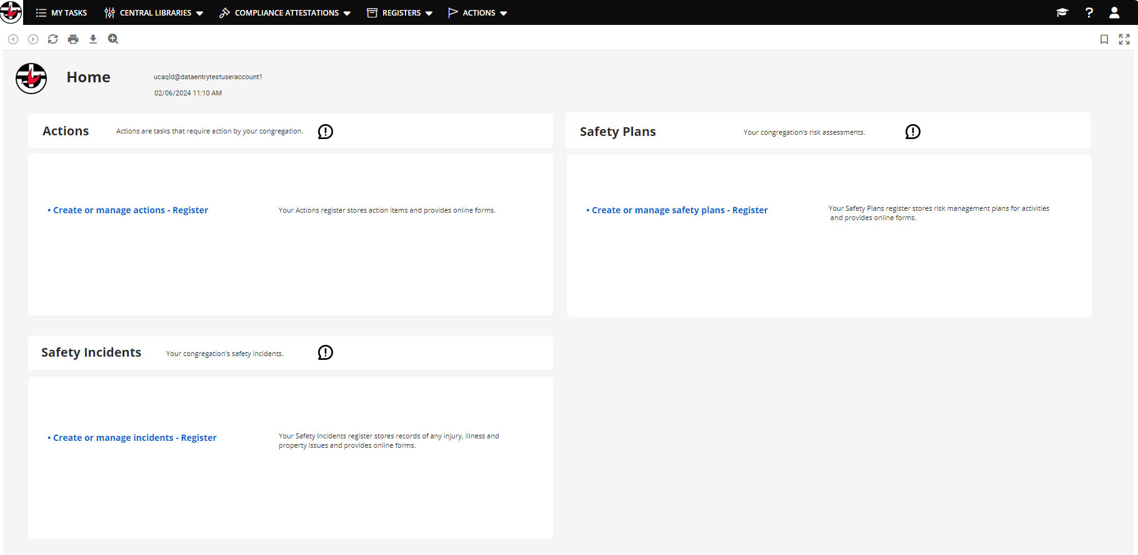
Make sure you’re on the correct login page
Audience | Correct login page
Login page for congregations and presbyteries | 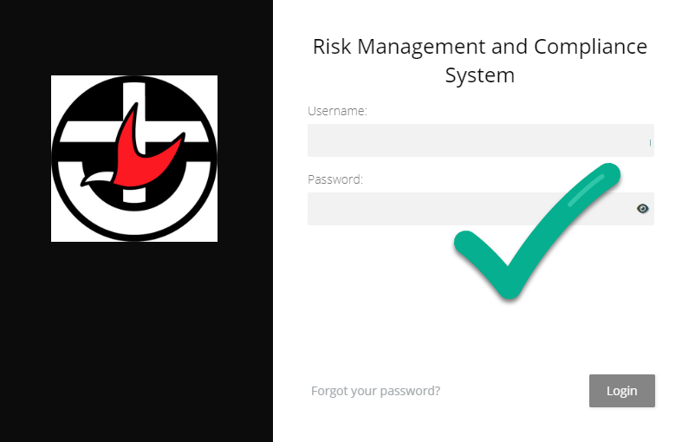
Login page for synod staff | 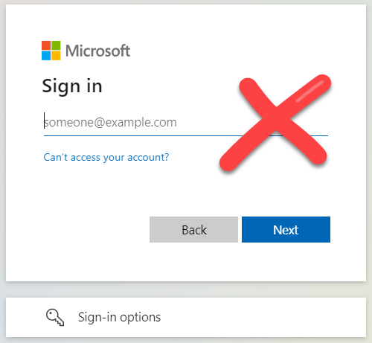
If the synod staff login page ever appears, use this link to go to the congregation login page. Congregation and presbytery staff will not be able to use the synod staff login page - your login will fail.
Save the login page as a favourite or bookmark
Please save the login page so you have easy access to the link for later.
- How to save a bookmark in Chrome.
- How to save a favourite in Safari.
- How to save a favourite in Edge.

Note: Make sure you save the login page as your favourite before you login. Do not save favourites/bookmarks after you login or you will have problems later being taken back to the synod login page.
Forgotten password
Follow this procedure:
- if you don't know or have forgotten your password
- to choose a new password - It's best practice to change your password to something only you know.

- Go to the congregation login page and click the Forgot your password link at the bottom of the page.
- Enter your username and your email. See above - these are exactly the same. That is, fill in your email address both in the Username and in the Email field.
- Retype the CAPTCHA text. Click the circular pair of arrows to generate another one if it's too hard to read.
- Click Reset password.

The system will now send a password reset link to your email address. Check your email now.

- Click the password reset link from your email and follow the prompts.
- Enter a password twice. It must:
- be at least 10 characters long
- not contain common words like password
- contain strong characters like numbers and symbols
Consider basing your password on a phrase to help meet these requirements and choose a memorable password e.g. Heat3piesfortea!

- Go to the congregation login page again.
- Enter your email address in Username and your new password. Click Login.

Once logged in, you will see the main launchpad page.
Revisions
Document number
Version | Approval date | Approved by | Effective date | Policy owner | Policy contact
1.0 | 03.06.2024 | Program Manager (Risk and Assurance) | 03.06.2024 | General Manager – Risk & Safeguarding | Program Manager (Risk and Assurance)
Next scheduled review |  | 03.12.2024

