Blessing of the Animals
St Francis Sunday

Introduction

Animals refer to all the living creatures people bring to worship, whether they be animals, such as cats and dogs, or birds, reptiles and fish, domesticated or wild. Where people are not able to bring an animal, they may wish to bring a picture of an animal they love or an endangered species in the wild.

Setting

This liturgy is best performed in a park, a public garden or the bush where it is lush and inviting. Space is needed between many of the animals to provide a comfortable context. All animals must be on a lead or in a secure pen for the safety of other animals. Most cities will give permission to use a park provided certain conditions are met. Banners with animals may also be used. It is uplifting if there are creatures such as birds naturally flying around. Groups like the RSPCA, Animal Welfare and others are usually happy to participate.

Special Focus

A special focus for this service is a public expression of the bond we have with animals. Through the service we are able to make them an integral part of our worship life and relationships.

Themes

In our call to worship we join with our animals and all animals to worship our Creator. In the psalm we call on all creatures to praise God. In our confession to recall how we may have hurt or neglected animals. In the readings we discover how animals are part of the family of God is Eden, how animals are created with greater glory than that of Solomon and how they will join in praise around the throne of the Lamb.

The Blessing

It is important to note that in the Scriptures the act of blessing means ‘the imparting of power or life.’ The person performing the blessing is mediating that power from God or Christ to the person or animal involved. To bless is more than an expression of goodwill or caring. To bless is impart God’s power in person!

The blessing of each animal, by name, means that health, healing and life are being mediated from God for the benefit of the animal in its relationship with its human partners. Shalom is one Hebrew expression of blessing.

Songs

A special song/hymn written in honour of St Francis is located in Habel Hymns Volume One. The melody is the well-known hymn Praise my Soul, the King of Heaven. The words follow.
MOTHER EARTH, OUR MOTHER BIRTHING

1. Mother Earth, our mother birthing
Ev’ry creature from the ground.
Jesus too was flesh and breathing,
Kin to all that’s green and brown.
Celebrate with all creation:
God has joined the web of life.

2. Sister Air, our sister lifting
Ev’ry creature born with wing;
Jesus shared the breath of forests,
Breath that makes our spirits sing.
Celebrate with all creation:
God has joined the web of life.

3. Brother Water, brother pulsing
Deep through ev’ry vein and sea,
Jesus drank the very raindrops
For our wine and in our tea.
Celebrate with all creation:
God has joined the web of life.

4. Father Fire, our father burning
With the sacred urge to live.
Jesus’ death completes the cycle,
Bringing life beyond the grave.
Celebrate with all creation:
God has joined the web of life.

Words: © Norman Habel 1999

St Francis Sunday
Blessing of the Animals
We worship with the creatures we love

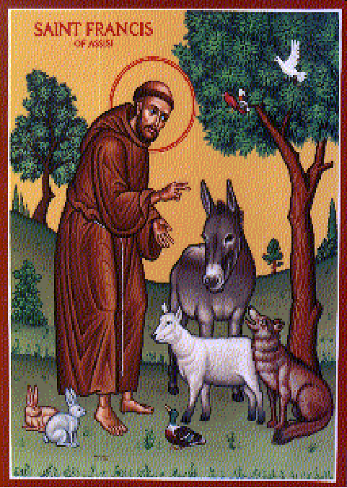

BLESSING OF THE ANIMALS

Welcome!
We worship this Sunday with all the creatures we love. We join the Psalmists and rejoice with all living things. We sing with the all the birds and animals that make our lives richer because of their presence.

Gathering

Leader Jesus Christ, we assemble with all your creatures in this circle of life.

People We ask you to join our circle and celebrate with us.

Leader Jesus Christ, as we join in celebration with you and all creation,

People We ask for your blessing, your shalom,
on the creatures present here that we love,
and all creatures celebrating in the wild.

Leader In the name of God, who creates all life,
In the name of Jesus Christ, who redeems all life,
and the name of the Spirit, who renews all life,
we cry with all in the circle of life:

People Shalom! Shalom! Shalom!
May your blessing come!

Procession and Song: “All things Bright and Beautiful”

All present who have brought an animal, or a picture of one, form a circle around the worshipping community, with space between the various animals. From there they join in this Psalm and cry loudly: Praise the Lord. It adds to the celebration if some animals bark or cry out during this time.

Circle of Praise – A Version of Psalm 148

L1 All dogs and dingoes, large and small:

P Praise the Lord!

L1 All rabbits, hamsters and guinea pigs:

P Praise the Lord!

L1 All goldfish, guppies and swimming creatures:

P Praise the Lord!

L1 All kookaburras, budgies and singing birds:

P Praise the Lord!

L1 All wombats, koalas and wallabies:

P Praise the Lord!

L1 All horses, cows and sheep:

P Praise the Lord!

L1 All lizards, skinks and crawling creatures:

P Praise the Lord!

L1 Every animal in the sky, the sea and the forest:

P Praise the Lord!

Thanks and Confession

We hold the animal we love and place our hand on its body as we give thanks.

L Lord, for all the animals in the whole wide world,

P We thank you, God!

L Lord, for all the fun and friendship we have with animals,

P We thank you, God!

L Lord, for all the times we have hurt or neglected animals,

P We are sorry.

L Lord, for all the times we have used poisons that have killed animals,

P We are sorry.

L Lord, for all the times we have destroyed the homes of animals
in the forests, oceans or fields,

P We are sorry.

Absolution

L. I speak for Christ. For all your sins against the creatures of Earth,
I forgive you and I call upon you to honour and protect all animals. Yes, I speak for Christ. May the animals of Earth be your companions in life and lead you to celebrate your place in the circle of life.

P Amen! Amen
Shalom! Shalom!

Christ Have Mercy

L As we come home to Earth.

P Christ, have mercy.

L As we seek to love our home.

P Christ, have mercy.

L As we seek to care for our kin.

P Christ, have mercy.

Glory to God

L Glory to God in the highest!

P And on Earth peace with our kin in creation!

Prayer for the Day

P God, our Creator, help us to love
all creatures as kin,
all animals as partners on Earth,
all birds as messengers of praise,
all minute beings as expressions of your mysterious design
and all frogs as voices of hope. Amen.

Readings for Blessing of the Animals

Old Testament: Genesis 218-25 ‘Animals created as partners’
God creates the animals and birds from the same ground that the first human is created. Animals and humans are kin and partners. Like children, the first human names the animals as part of a living family in Eden.

Psalm: Ps. 148 ‘All creatures praise the Lord’

Epistle: Revelation 5.11-14 ‘Animals around the throne”
In this vision of the future, it is not only angels that praise Christ on the throne, but also the living creatures of Earth and sky. They are an integral part of our hope and our future.

Gospel: Matthew 6 25-29 ‘How God has made creation beautiful’
Solomon is all his royal splendour cannot match the brilliance of the creatures of land and sky that God creates and feeds.

Reading from a Sermon of St Francis: ‘Peace, birds, peace!’

My brother and sister birds, you should greatly praise your Creator
and love him always. He gave you feathers to wear, and wings to fly,
and whatever you need. God made you noble among his creatures
and gave you a home in the purity of the air, so that, though you do not
sow nor reap, he nevertheless protects and governs you without your
least care.

Affirmation of Faith – The Apostles Creed

Passing of the Peace

L Let us share the peace of the Lord with one another,
and to our animals.

P The peace of the Lord be with you

Song: “All God’s Critters”

Sermon or Reflection

Song: “Let All Things now Living”

Offering Prayer

L God, our Creator, through your love you have given us these
gifts to share. Accept our offerings as an expression of our deep thanks for all the animals and other creatures that have enriched our lives.

- With all animals around the throne, we bless the Lamb of God.

Circle of Blessing

All worshippers with animals now form another circle, each person placing a hand on the animal being held. The leader then moves to each animal, saying its name, holding a hand over the animal, and blessing it in the name of the Cosmic Christ who fills and heals creation.

Blessing: ‘Fido, the power of this blessing from Christ fill you with life,
bind you to your human partners and lead you to praise your Creator. Amen.

The Great Thanksgiving

L The Creator be with you and all creation.

P And also with you.

L Open your hearts.

P We open them to our Creator.

L Let us give thanks to our Creator.

P It is right to join creation in thanking God.

L It is right to give you thanks, loving Creator.
Your Word is the impulse for all things to be,
for space, stars and stardust to appear,
for Earth to emerge from the deep,
for life to be born of Earth and
for humans to be born of Earth and the Spirit.

You chose to be born a human being,
to become a part of Earth,
to suffer, die and rise from death
to redeem humankind, renew creation,
and affirm all born of Earth and the Spirit.

Your presence is the living impulse in all things,
the Christ deep among us,
filling Earth—land, sea and air;
filling every element and place;
filling the grain and the grape
we share with you this day.

Therefore with angels and archangels,
ancient voices in the forest,
high voices from the sky,
deep voices from the sea
and the whole company of creation,
we proclaim your presence among us

P. Holy, holy, holy, God of all life,
Earth and sea and sky
and all things that exist
are full of your presence
and glorify your name. Amen

Lord’s Prayer

Words of Institution

Invitation

C Come, for all things are now ready.

Come to the table with all your kin
and share with all in need:
the gift of healing for those in pain,
the gift of forgiveness for those in sin,
the gift of assurance for those in doubt,
and the gift of hope for those in tears.

P May we who share these gifts,
share Christ with one another
and all our kin.

Lamb of God

P Lamb of God, who takes away all sin against God,
have mercy on us.
Lamb of God, who takes away all sin against Earth,
have mercy on us.
Lamb of God, who takes away all sin from the world,
receive our prayer.

Distribution

Distribution Songs

Thanksgiving

L Let us give thanks for this meal.

P We thank you Christ, for the meal we have celebrated with you and we pray that through your body and blood we may be healed and become agents of healing for Earth. Amen.

Sending Out

L Christ calls you to be his disciples,
to serve him with love and compassion,
to serve Earth by caring for her creatures.

Will you care for creation?

P We will care for creation!
We will nurture our animals!
We will celebrate the circle of life with them!

Blessing

L May the Spirit of God, who is above all and in all and through all,
fill you with the knowledge of God’s presence in Earth
and the pulsing of Christ within you.
Go in peace!
Serving Christ and loving all creatures!

P We go in peace,
serving Christ and loving our animal kin.

Recession and Song: “All Creatures of our God and King”

